12.18

Monthly analysis:

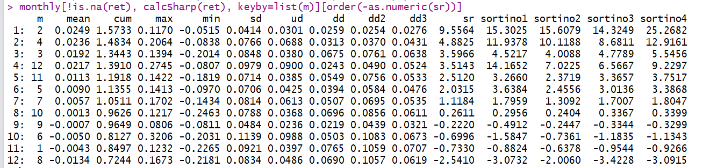

Ranked by sharpe ratio. Look at downward deviation (this is a measure of crash risk)

Jan is not good.

Feb-Apr is position building period.

Dec/Nov is end of year rally. If it’s up it’s up big, if it’s down it’s down small.

Rank by dd ( crash risk): Jan has the biggest downside sd and limited upside sd, something to be careful about. Feb and april are good.

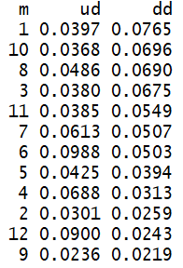

Rank according to sd:

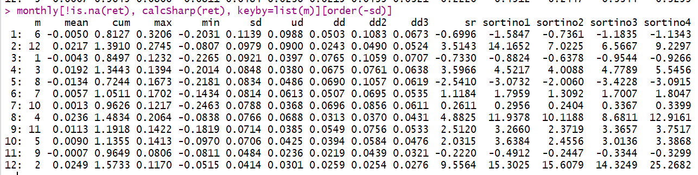

Jun, dec and Jan are very volatile.

Feb has very good risk/return profile, with highest sr.

By mean:

Jan: uncertainty, selloff

Sep: flattish.

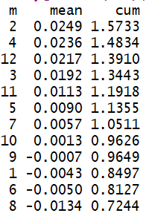

Next year: jan keep a light positioning. Avoid aggressive trading.

Feb/Mar/Apr(best quarter) : aggressive.

Dec/Nov/Oct: worse than year beginning but better than mid year

Jun/jul/aug/Sep: Worst period of the year. (summer?) 2015 market crash was during this time.

Early part of the year is position building. Summer will see some profit taking.

Avoid Jan the same way as you would avoid Mondays. Volatility of early trading.

One word to describe each month: (light green semi tradable, full green very tradable, red is to be avoided or trade with light positioning). Year beginning position need to keep low to avoid January downside dd.

1. Crash risk
2. Building
3. Shaky
4. Regain
5. Flat
6. Correct
7. Rest
8. Correct
9. Correct
10. Flat
11. Fight
12. Last chance

Blue chips:

Moutai’s 10% correction was enough to throw out most people (including me).

People entered too early, but position acc and dec should be on a monthly basis.

XUtrader improvements:

**General trading:**

Trade post crash days, enter in pm, there is adequate risk compensation.

**Market open:**

Index closed at 12908, fut down to 12870 then currently trading at 12965.

(PD From -0.3 to +0.4).

Entrance on discount, take overnight risk. (PD swings are pretty big).

Pay close attention to the PD swings.

XUTrader augmentation

1. Week to date PD. (how to save index data)

Strategy

12.19

How to profit from US market strength:

Overnight movements are usually heavily influenced by the US market.

When US market is bull, discount tends to lessen during overnight session.

Today’s tradability (out of 5): 0/5

Reason: ytd there was a pm rebound which places pressure on today’s pm.

No other advantages.

Cut to how much position? 5 lot.

9:57

Losing on trend pnl here. That's ok. Ytd’s HO was good.

More certain sources of pnl are close discount buying + PM reversion.

Several time points to carefully check for tradability:

1. Open at 9 (sell previous position)
2. The rest of the AM: Not much. Random checking, no trading
3. PM: check for trading opportunity if previous PM was down
4. Close: just look
5. Check from 4:00 to 4:30, if fut keeps dropping into deep discount, pick up here
6. Overnight session: buy if in deep discount

1439

Market stronger than expected, mostly helped by ytd’s HO and CH.

Trend pnl strong

After market:

Cutting delta in AM was correct and should be done consistently, with the rest of the delta on trend tightly controlled. It is not a source of primary PNL.

510050 should be used since it has no stamp and it can be hedged fully with futures. It makes it easier to hedge AM risk and expose delta for PM.

**12.20.2017**

Fut rolling into Jan: be extra careful. Keep trend delta to the minimum.

Only traded PD delta in Jan 2016, worked well.

Current trend delta: 4, down from last month’s 6.

First quarter ex-Jan (Feb-Apr) is the strongest.

Nov/Dec/Oct comes second.

May-Sep mediocre.

Jan very volatile (same way as Monday volatility, with new policies)

Dec: position cutting in expecting Jan might begin in late nov/dec.

Stock Strategy:

**12.21.2017**

Fut opened flat pd, dropping into a discount -0.2%, following 2 days of rally.

Correction is needed here.

Hold on the throttle for today and tomorrow.

1141

Trend pnl continue to be positive. Market way stronger than expected.

Residual delta just reaps off this pnl.

Not much reason to trade around here. Just leave the position as is.

**12.22**

Following unexpected market rally yesterday (which I didn't understand). Today also hold position as is.

This month there was trading error 2 weeks ago which resulted in liquidation. There has not been a trade since Dec 8. Delta has been minimal. Trading error was due to following an up Tuesday bought on the morning on Wed and market corrected until close of Thurs.

After the recent events, it is more clear that you should trade only the pm/close **following a low closer**.

When markets keep going up, it is not smart to add position. On the day of correction it is also not smart to add position. Wait until market crashes and there are no buyers (when there are pm rebound, it is not the end of a correction), then when traders cut their short term position, the rebound is about to happen.